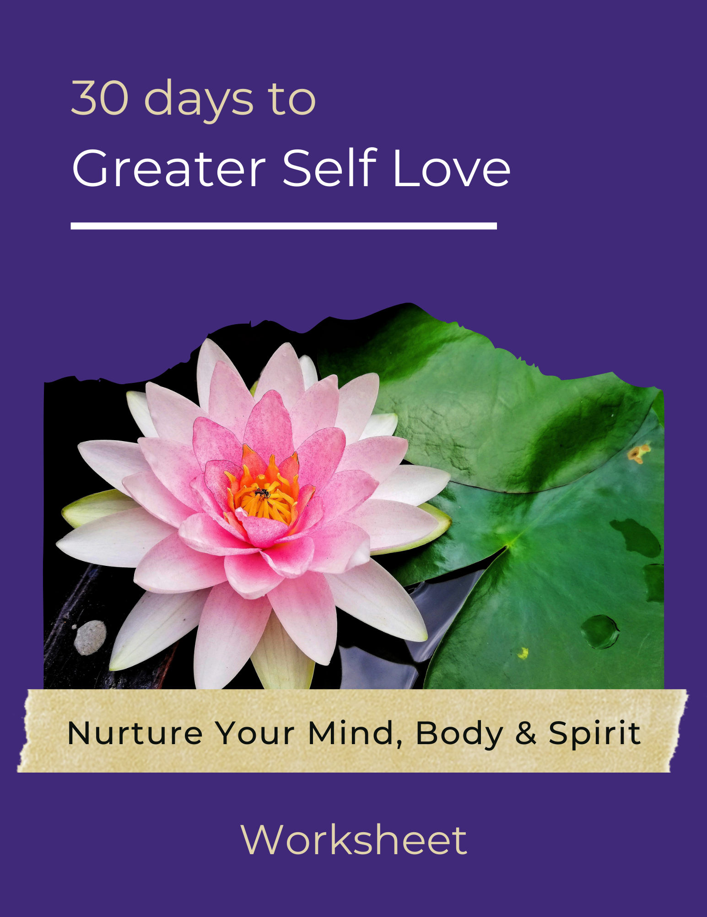

Answer these questions to gain a better perspective of how you can strengthen your self-love.

- How do I determine my self-worth? Is that fair?

- In what ways do I treat my close friends better than I treat myself?
- In what ways do I treat strangers that I encounter throughout the day better than I treat myself?
- What are five things that I think everyone should be able to do that I currently cannot?
- What are three different options for regular exercise that I would enjoy?
- What are three things that I enjoy doing? How can I add time to do these things into my schedule?
- What do I admire most about my body?

- What are 10 things in my life that make me feel lucky and grateful?
- What are the common qualities of those I admire the most?
- What makes me feel good about myself? How can I bring more of this into my life?

