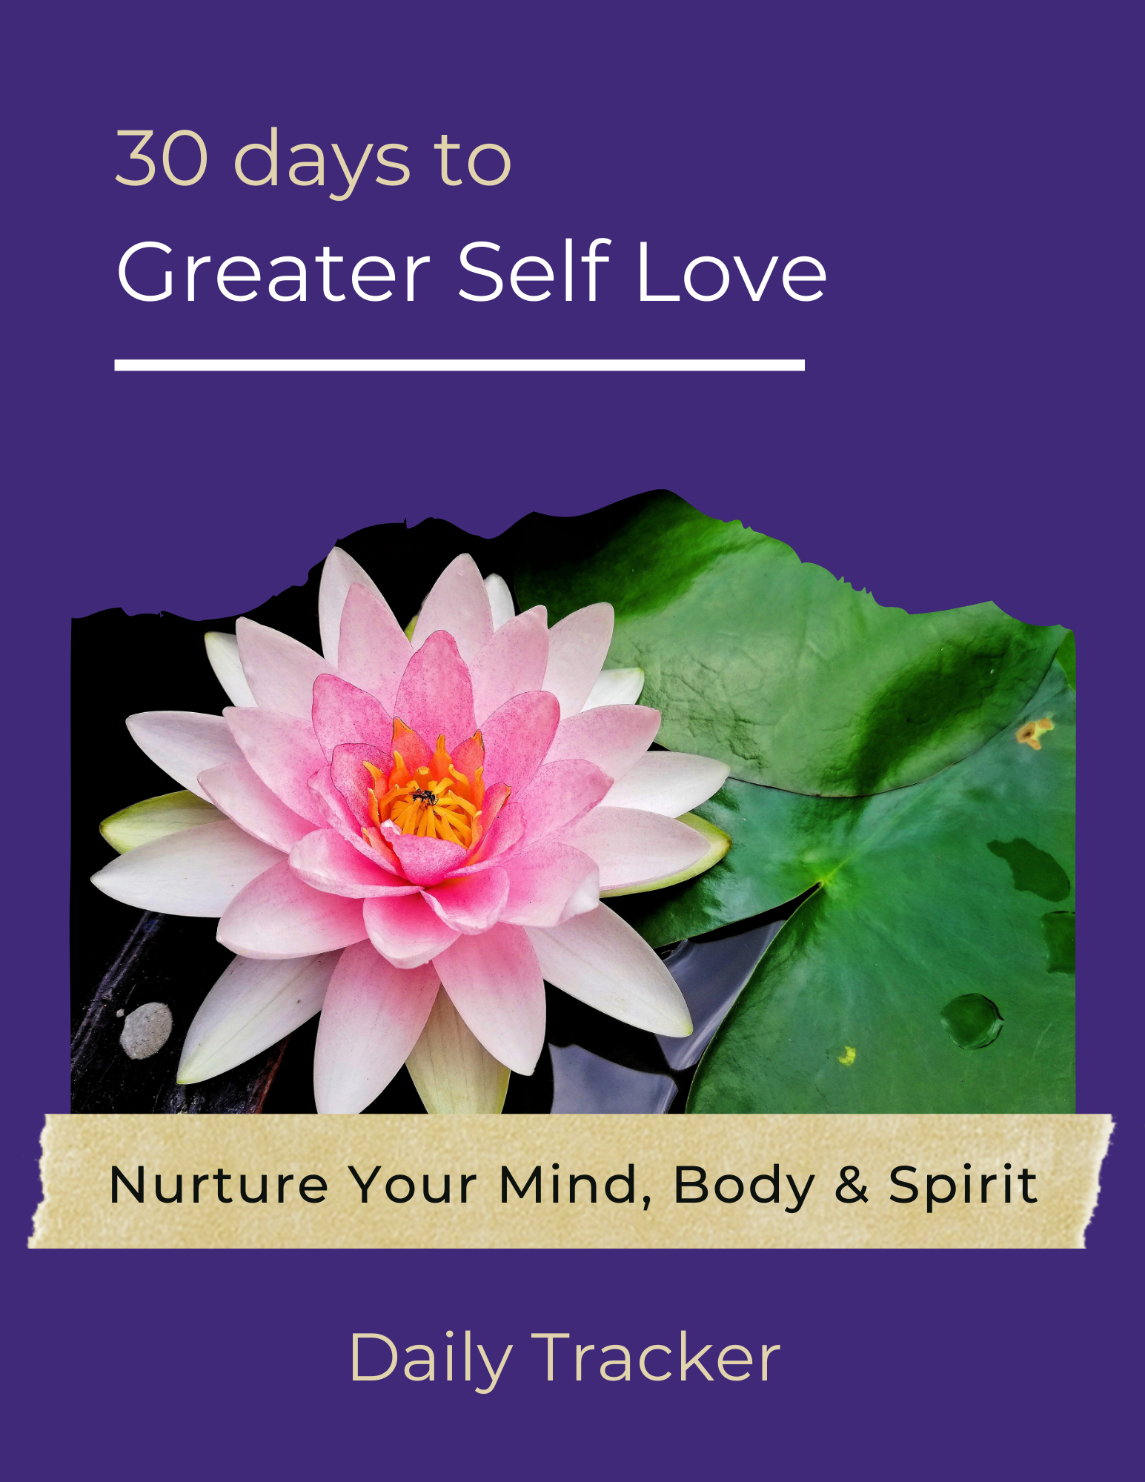

Self-Love Daily Tracker

Day | Activity | Did you do it? | How Do you feel about it?
0 | Set your intention for the next 30 days.
1 | Become aware.
2 | Accept all the compliments that come your way.
3 | Start reading a book on the topic of self-love.
4 | Create and use affirmations.
5 | Do something you’ve always wanted to do.
6 | Admire your body.
7 | Eat nutritiously.
8 | Send yourself a love letter.
9 | Ask someone for a favor.
10 | Remove the need for perfection.
11 | Declutter your home environment.
12 | Clean up your schedule.
13 | Develop a strategy for dealing with stress.
14 | Create a gratitude list.
15 | Exercise.
16 | Clean up your social life.
17 | Do what you love.
18 | Make plans for your future.
19 | Keep a journal.
20 | Forgive yourself.
21 | Stop seeking approval.
22 | Sit by yourself.
23 | Visit the doctor and dentist.
24 | Volunteer.
25 | Sleep.
26 | Set and maintain boundaries.
27 | Do one thing you know you need to do.
28 | Trust your intuition.
29 | Do something that makes you like yourself more.
30 | Do something for someone else but keep it a secret.
31 | Have fun.

