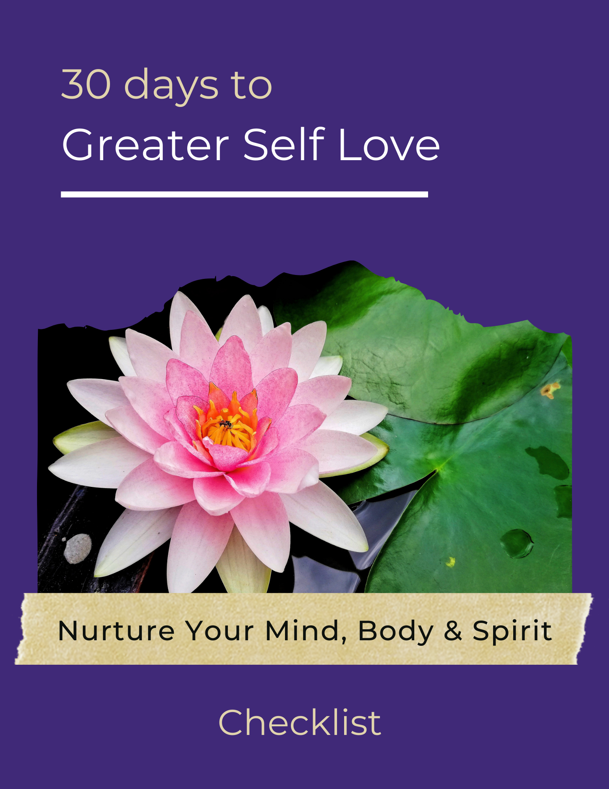

Now that you’ve spent a month enhancing your self-love, it’s important to take the significant momentum you’ve created and carry it into the future. Keep the ground you’ve gained and continue moving forward.

One way to stay on track is to use a daily checklist. This checklist will help you to nurture your self-love on a daily basis.

Feel free to add any new ideas you might have. Plus, there may be additional things that you might want to do on a weekly basis, such as doing something that makes you like yourself more. Or, you might want to make something a priority that isn’t even mentioned on this list.

It’s your checklist - customize it for you!

Self-Love Checklist
- List five things that fill me gratitude.
- List five things that I like about myself.
- Read on the topic of self-love or self-esteem for 15 minutes.
- Eat a healthy breakfast.
- Eat a healthy lunch.
- Eat a healthy dinner.
- Exercise for 20 minutes.
- Repeat affirmations at least twice.
- Send myself a quick self-love message.
- Make a request of someone.
- Declutter a room for 10 minutes.
- De-stress for at least 15 minutes.
- Spend time doing something I love.
- Write in journal for 10 minutes.
- Do something that needs to be done.
- ___________________________________________________
- ___________________________________________________
- ___________________________________________________
- ___________________________________________________
- ___________________________________________________
- ___________________________________________________
- ___________________________________________________
Use this checklist each day until you get into the habit of doing things that make you feel good about yourself throughout the day. Enjoy this journey and see your self-love grow!

